Design Planning

# UML Diagrams

## Structure Diagrams

* Class Diagram - depicts the static structure of a system by showing system’s classes, their methods and attributes. Class diagrams also help us identify relationship between different classes or objects.

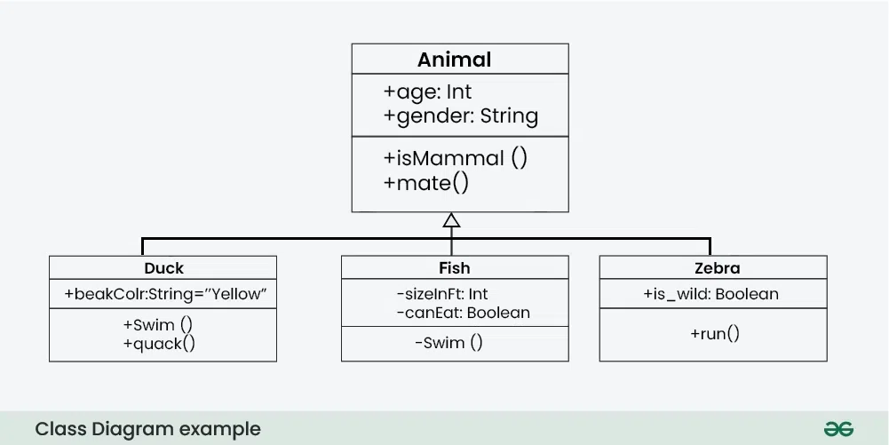

## Behavior Diagrams

* Activity Diagram - illustrate the flow of control in a system and refer to the steps involved in the execution of a use case. An activity diagram models sequential and concurrent activities; depicts workflows visually; focuses on condition of flow and the sequence in which it happens; and depict what causes a particular event using an activity diagram.

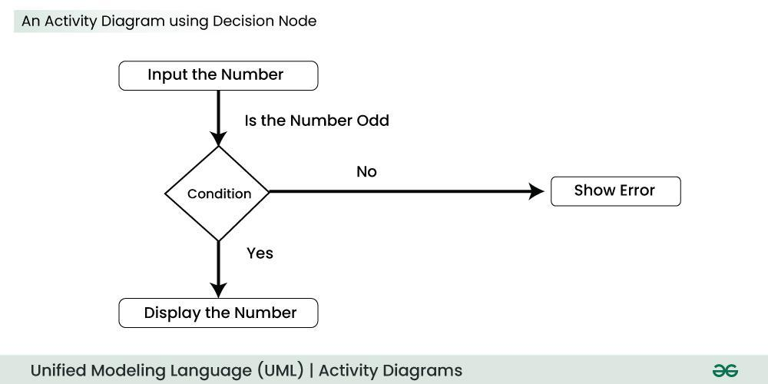

* Interaction Diagrams
  + Sequence Diagram - depicts interaction between objects in a sequential order i.e. the order in which these interactions take place. Sequence diagrams describe how and in what order the objects in a system function.

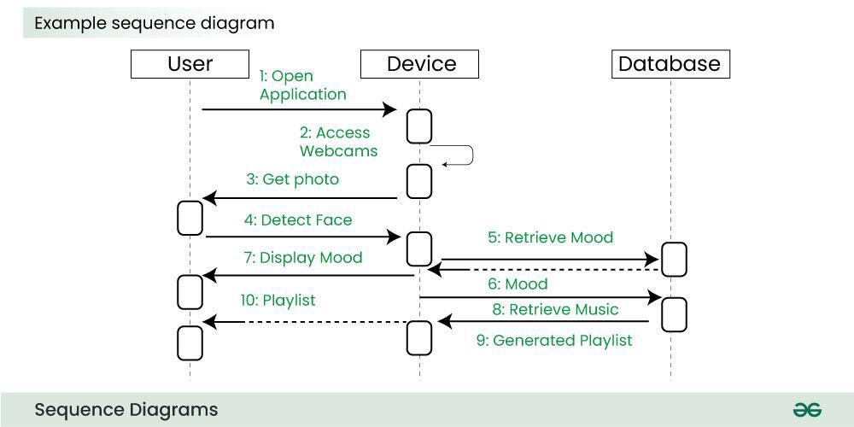

* Use Case Diagram - depicts the functionality of a system or a part of a system. They are widely used to illustrate the functional requirements of the system and its interaction with external agents(actors).

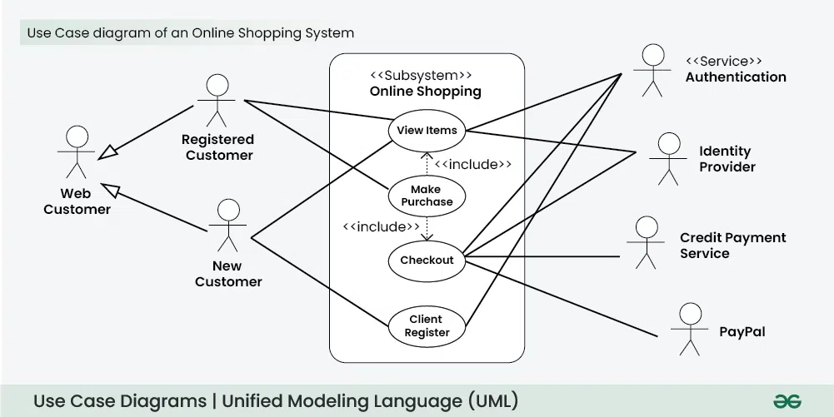

# Other Diagrams

## Structure Diagrams

* Mind Map/Site Map - a visual organizational tool that uses a central concept or idea, surrounded by branches that represent related ideas and subtopics. It's a way to brainstorm, organize thoughts, and create connections between different pieces of information.

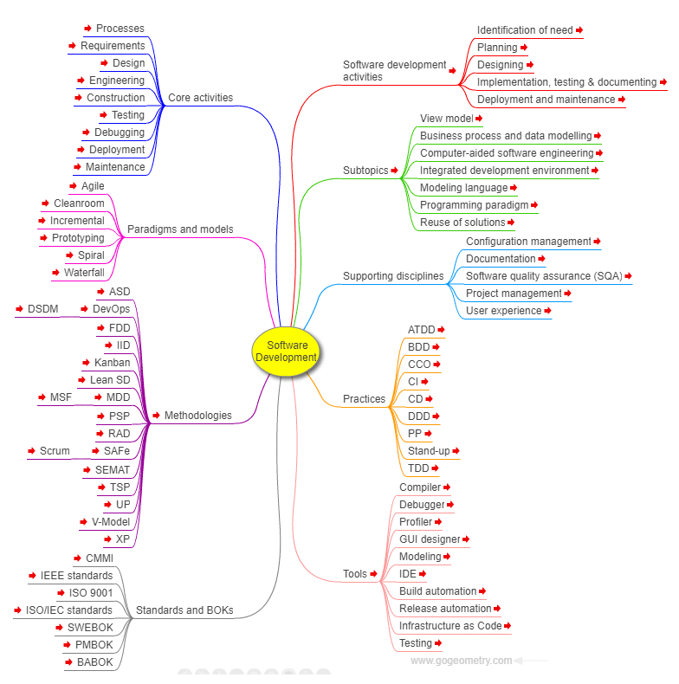

* Salt (GUI Designer) - a subproject included in PlantUML to design graphical interfaces.

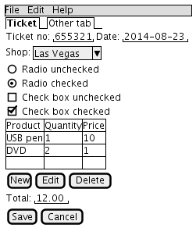

* Entity-Relationship Diagram - a visual representation that shows how different entities relate to each other within a system, often a database or a business process.

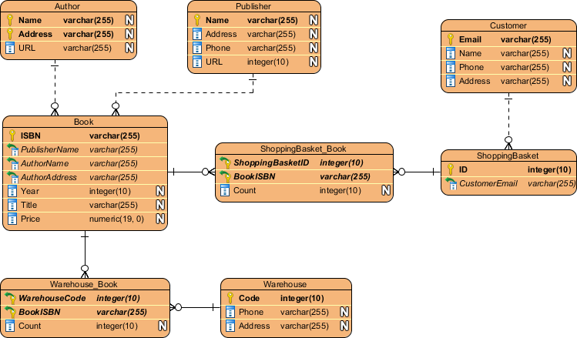

## Project Management Diagrams

* Work Breakdown Structure Diagram (WBS) - a hierarchical decomposition of a project into smaller, more manageable components or tasks. It's a visual representation that breaks down the entire project scope into a clear, organized structure, making it easier for project teams to plan, schedule, and track progress.

